Kianté A. Fernandez

5/5/2020

tt2 <- ttheme_default()  
  
grid.arrange(  
 tableGrob(summary(batch.1), theme=tt2),  
 tableGrob(summary(batch.2), theme=tt2),  
 nrow=2)

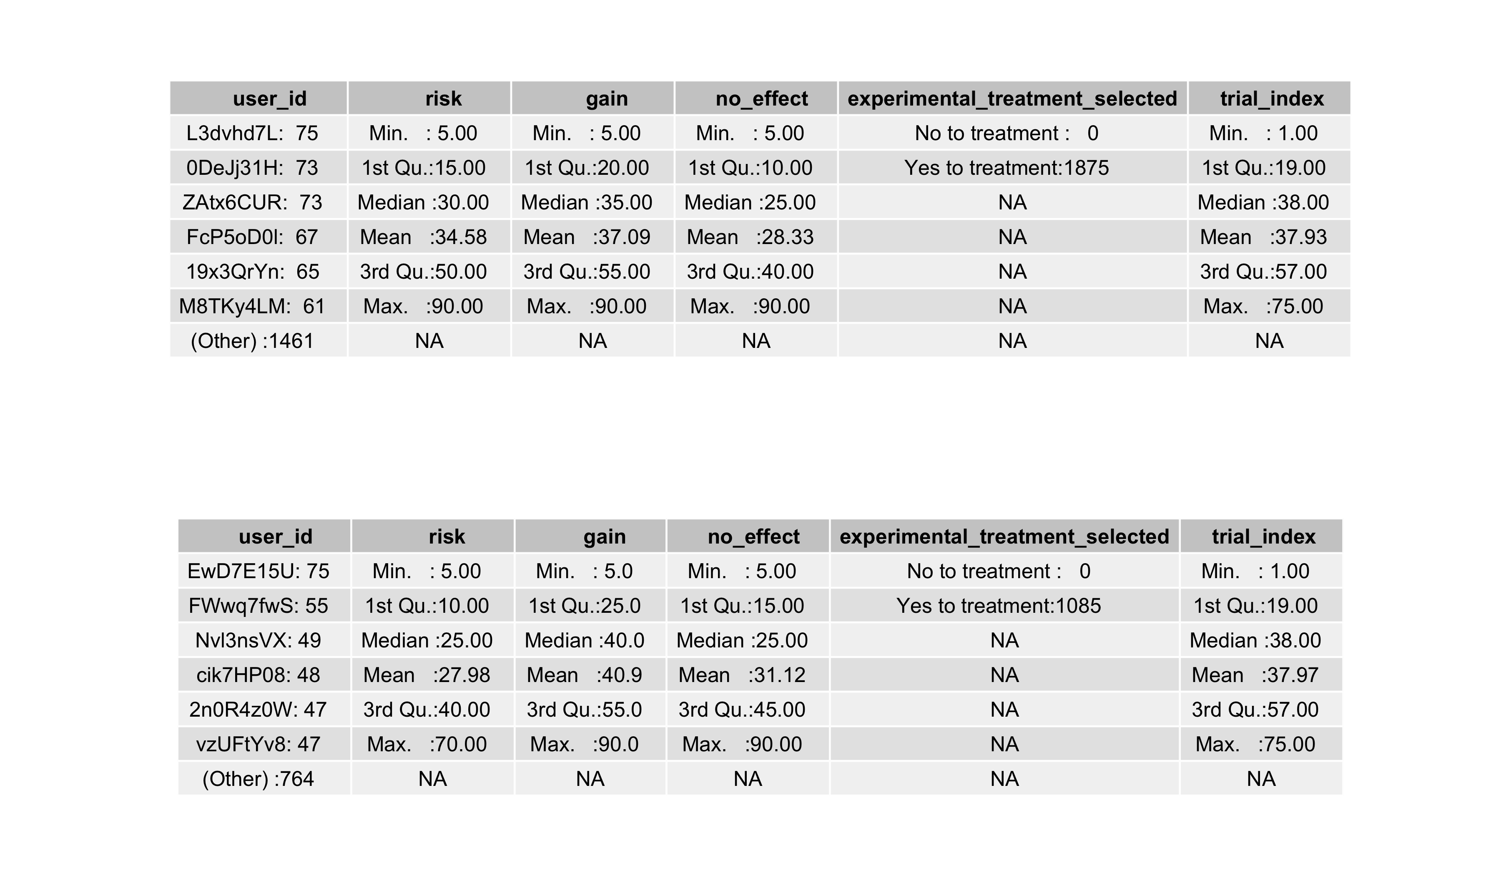

All to see here is that batch to has a max of 70.

grid.arrange(p1,p2,p3,p4,p5,p6, ncol = 2)

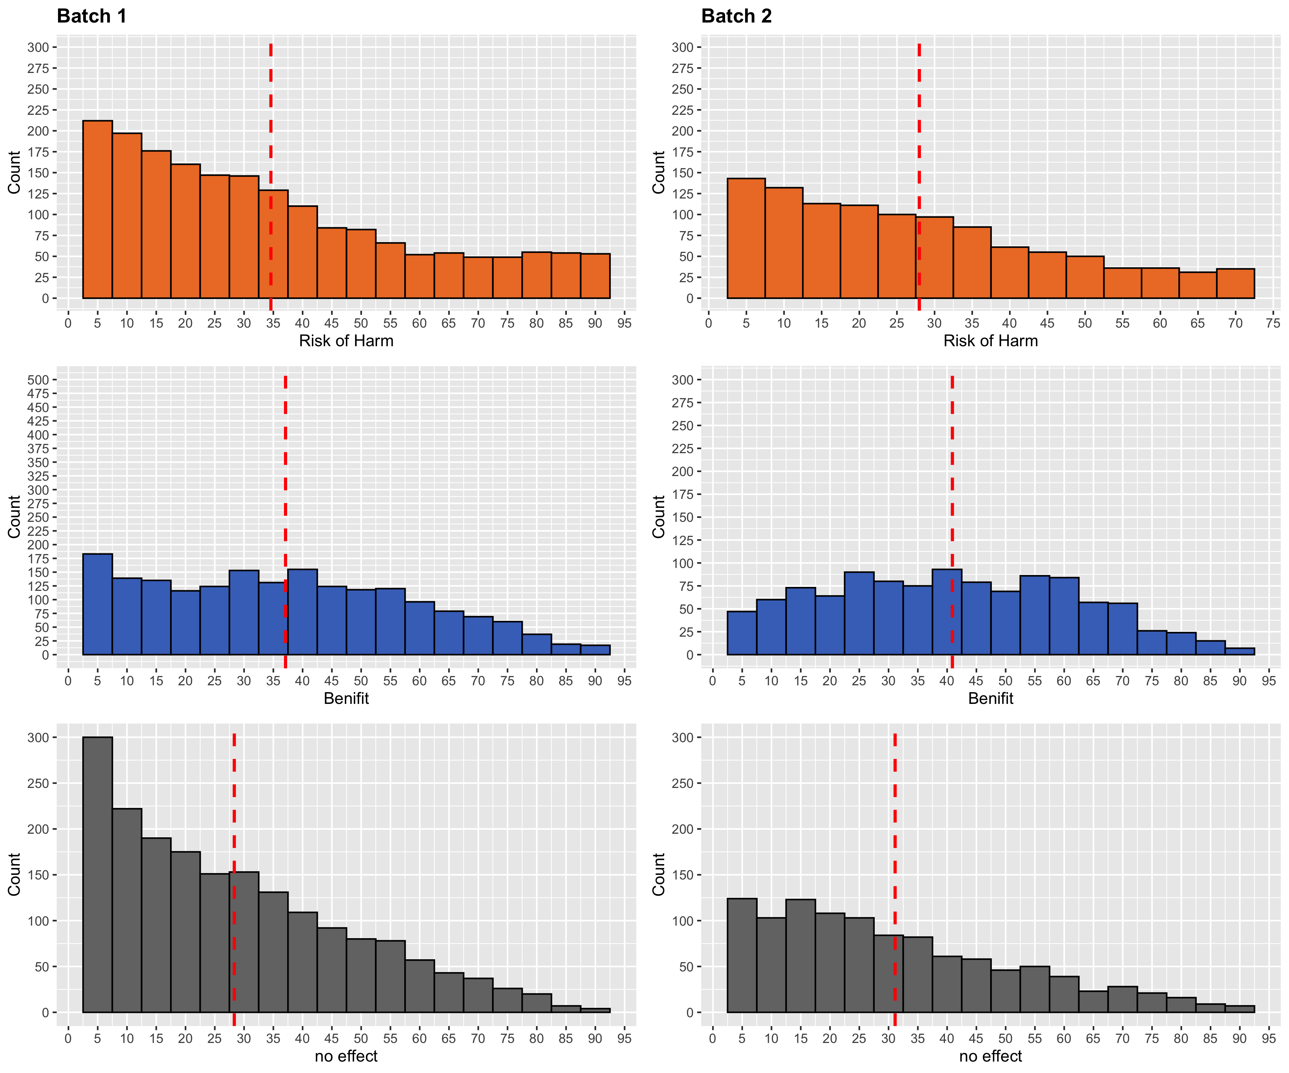

## Warning: Groups with fewer than two data points have been dropped.

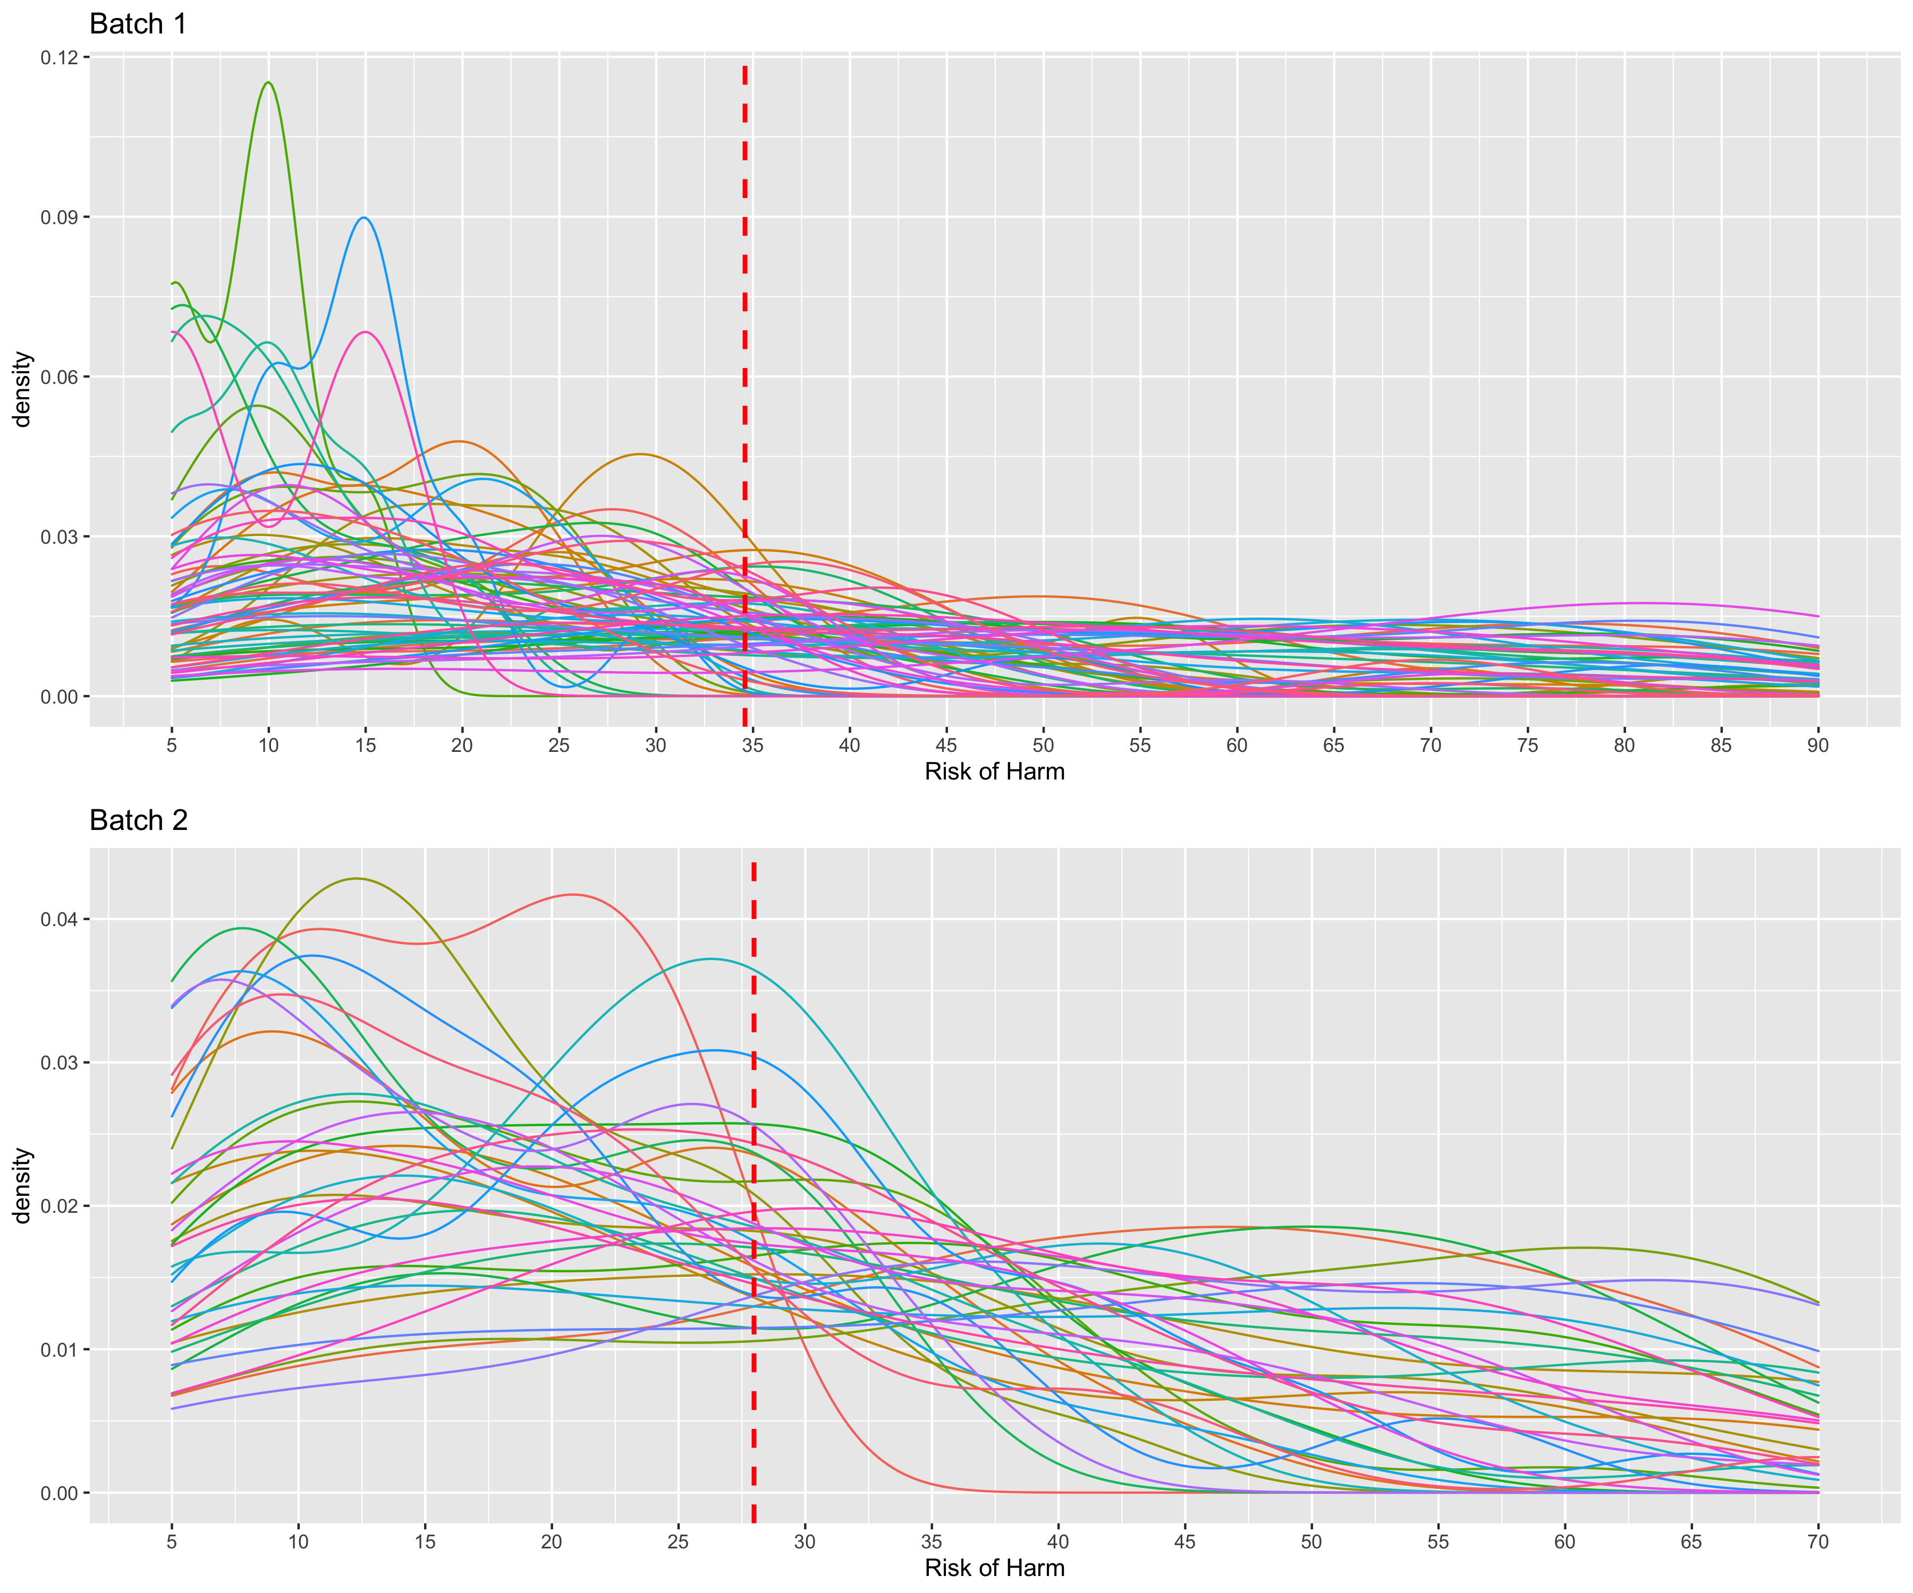

## Warning: Groups with fewer than two data points have been dropped.

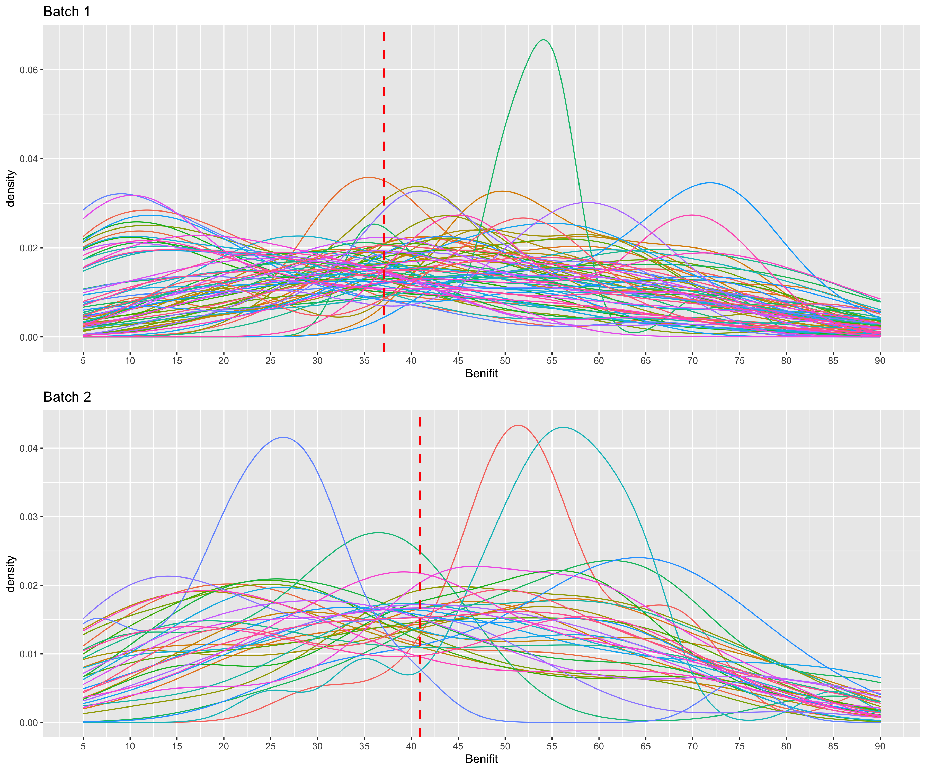

## Warning: Groups with fewer than two data points have been dropped.

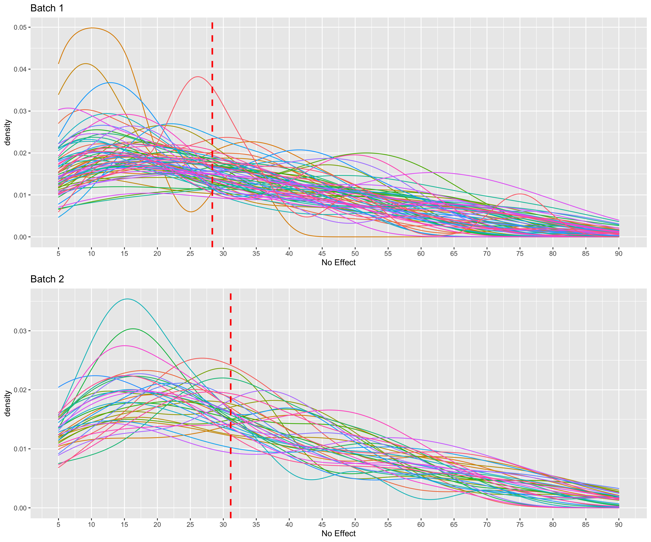

|  |  |  |
| --- | --- | --- |
|  | No | Yes |
| 1mvqe1Y3 | 57 | 18 |
| 2n0R4z0W | 28 | 47 |
| 4lsMLrPn | 41 | 34 |
| 8huJxZZ7 | 53 | 22 |
| aTDPLvkF | 63 | 12 |
| AyjDXCOl | 59 | 16 |
| cik7HP08 | 27 | 48 |
| clGGPSOW | 56 | 19 |
| cLZrBIi5 | 35 | 40 |
| cR3c5iQJ | 33 | 42 |
| EwD7E15U | 0 | 75 |
| FIvIqXVg | 32 | 43 |
| FWwq7fwS | 20 | 55 |
| gd68nvgO | 58 | 17 |
| jTj8r7IM | 61 | 14 |
| KZDOCQto | 42 | 33 |
| n03QfmuA | 44 | 31 |
| NEFYx2OX | 50 | 25 |
| Nvl3nsVX | 26 | 49 |
| QKdkcfRJ | 53 | 22 |
| rPZzRp35 | 56 | 19 |
| RU3gTWzp | 39 | 36 |
| SlQwUBGa | 59 | 16 |
| ssbyd1eW | 57 | 18 |
| T7tIrld6 | 43 | 32 |
| tTZWd9tg | 39 | 36 |
| V8H6BSKF | 42 | 33 |
| vzUFtYv8 | 28 | 47 |
| WFQRR38I | 43 | 32 |
| WHBunwtP | 34 | 41 |
| xnl8QeZb | 53 | 22 |
| YVHXvkQg | 49 | 26 |
| z7YfiyEK | 42 | 33 |
| Zg8wzJ7p | 43 | 32 |

|  |  |  |
| --- | --- | --- |
|  | No | Yes |
|  | Min. : 0.00 | Min. :12.00 |
|  | 1st Qu.:34.25 | 1st Qu.:19.75 |
|  | Median :43.00 | Median :32.00 |
|  | Mean :43.09 | Mean :31.91 |
|  | 3rd Qu.:55.25 | 3rd Qu.:40.75 |
|  | Max. :63.00 | Max. :75.00 |

## Interpretation